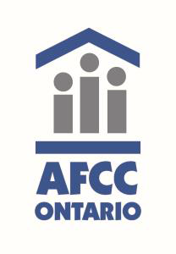
Ninth Annual AFCC Ontario AGM & Conference
The Association of Family and Conciliation Courts (Ontario Chapter) invites you to the 9th Annual Conference, Breaking Down Barriers: Targeting Resources to Meet Families’ Needs
Please join us at the 2017 conference on October 19th (afternoon and evening) and 20th (day), as we explore the challenges faced by families and professionals in the current environment.
October 19, 2017 Events (YMCA Downtown Toronto)
We invite New Professionals to join us on Thursday October 19, 2017 from 1:00 p.m. to 2:30 p.m. for an enlightening panel discussion, “Advice from the Bench”.
The Pre-Conference Institute, entitled, Addiction in Family Breakdown: The Challenge and Complexities” will be held from 2:45 p.m. to 5:00 p.m. Our panel will explore the multi-dimensional issues that arise in cases involving addictions, and the impact of addictions on the family law and child protection justice systems.
The Annual AFCC-O Social Event takes place from 5:00 pm to 7:00 pm at Pogue Mahone Pub & Kitchen, 777 Bay Street.
October 20, 2017 AGM and Annual Conference, Breaking Down Barriers: Targeting Resources to Meet Families’ Needs (Toronto Reference Library),
Opening the annual conference is our keynote speaker, Dr. Arnold Shienvold, in a session entitled “Cadillac vs. Chevy – How do we balance the push and pull of limited resources?” Dr. Shienvold, a past president of AFCC (Parent) specializes in dealing with high conflict families, and he is an expert in custody evaluations and mediation.
or questions please contact: info@afccontario.ca; andrea.himel@rogers.com or bburke@epsteincole.com Registration NOW OPEN

